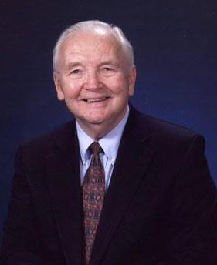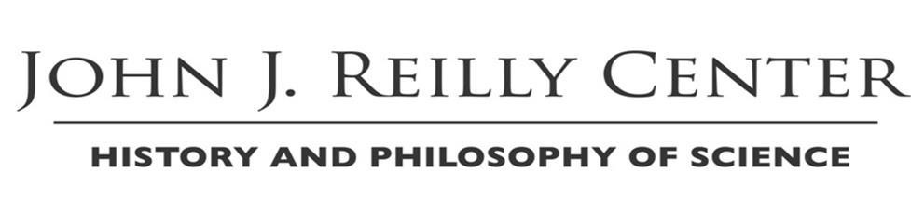Book Launch Talk
The Gestalt Shift in Conan Doyle’s Sherlock Holmes Stories
with Professor Michael J. Crowe

“A New Interpretation of the Sherlock Holmes Stories Based on Thomas Kuhn’s Idea of Gestalt Shift”
Thursday, Nov. 29, at 5 p.m.
Oak Room, South Dining Hall

Michael J. Crowe is the Rev. John J. Cavanaugh, C.S.C. Professor Emeritus in the Program of Liberal Studies and Graduate Program in History and Philosophy of Science at the University of Notre Dame.
This is his eleventh book.

A Book Launch Sponsored by

